HTI Filtration Inc..

SYSTEM SPECIFICATION SHEET

HS410-C1-B6Q-B

Model # 810-015, and 810-024

Systems Description: The HS410-C1-B6Q-B filtration system, is designed to remove moisture, sludge and hard particulate from heavy duty gear lubricants up to 1000 SUS viscosity. The filtration system features a rugged, floor mount stand and comes complete with all required hoses, valves and connection fittings. The heart of the system is the unique, high capacity 400 Series Hydra-Supreme filtration element that has proven itself capable of maintaining new oil quality over extended periods of time thus greatly extending the time between periodic lube replacement and reducing internal wear in the gear box. This system has proven applications on lauter tun, mash tun and cooker drives boxes in brewing operations as well as other applications where water and high shear characteristics create premature wear on the drive gears.

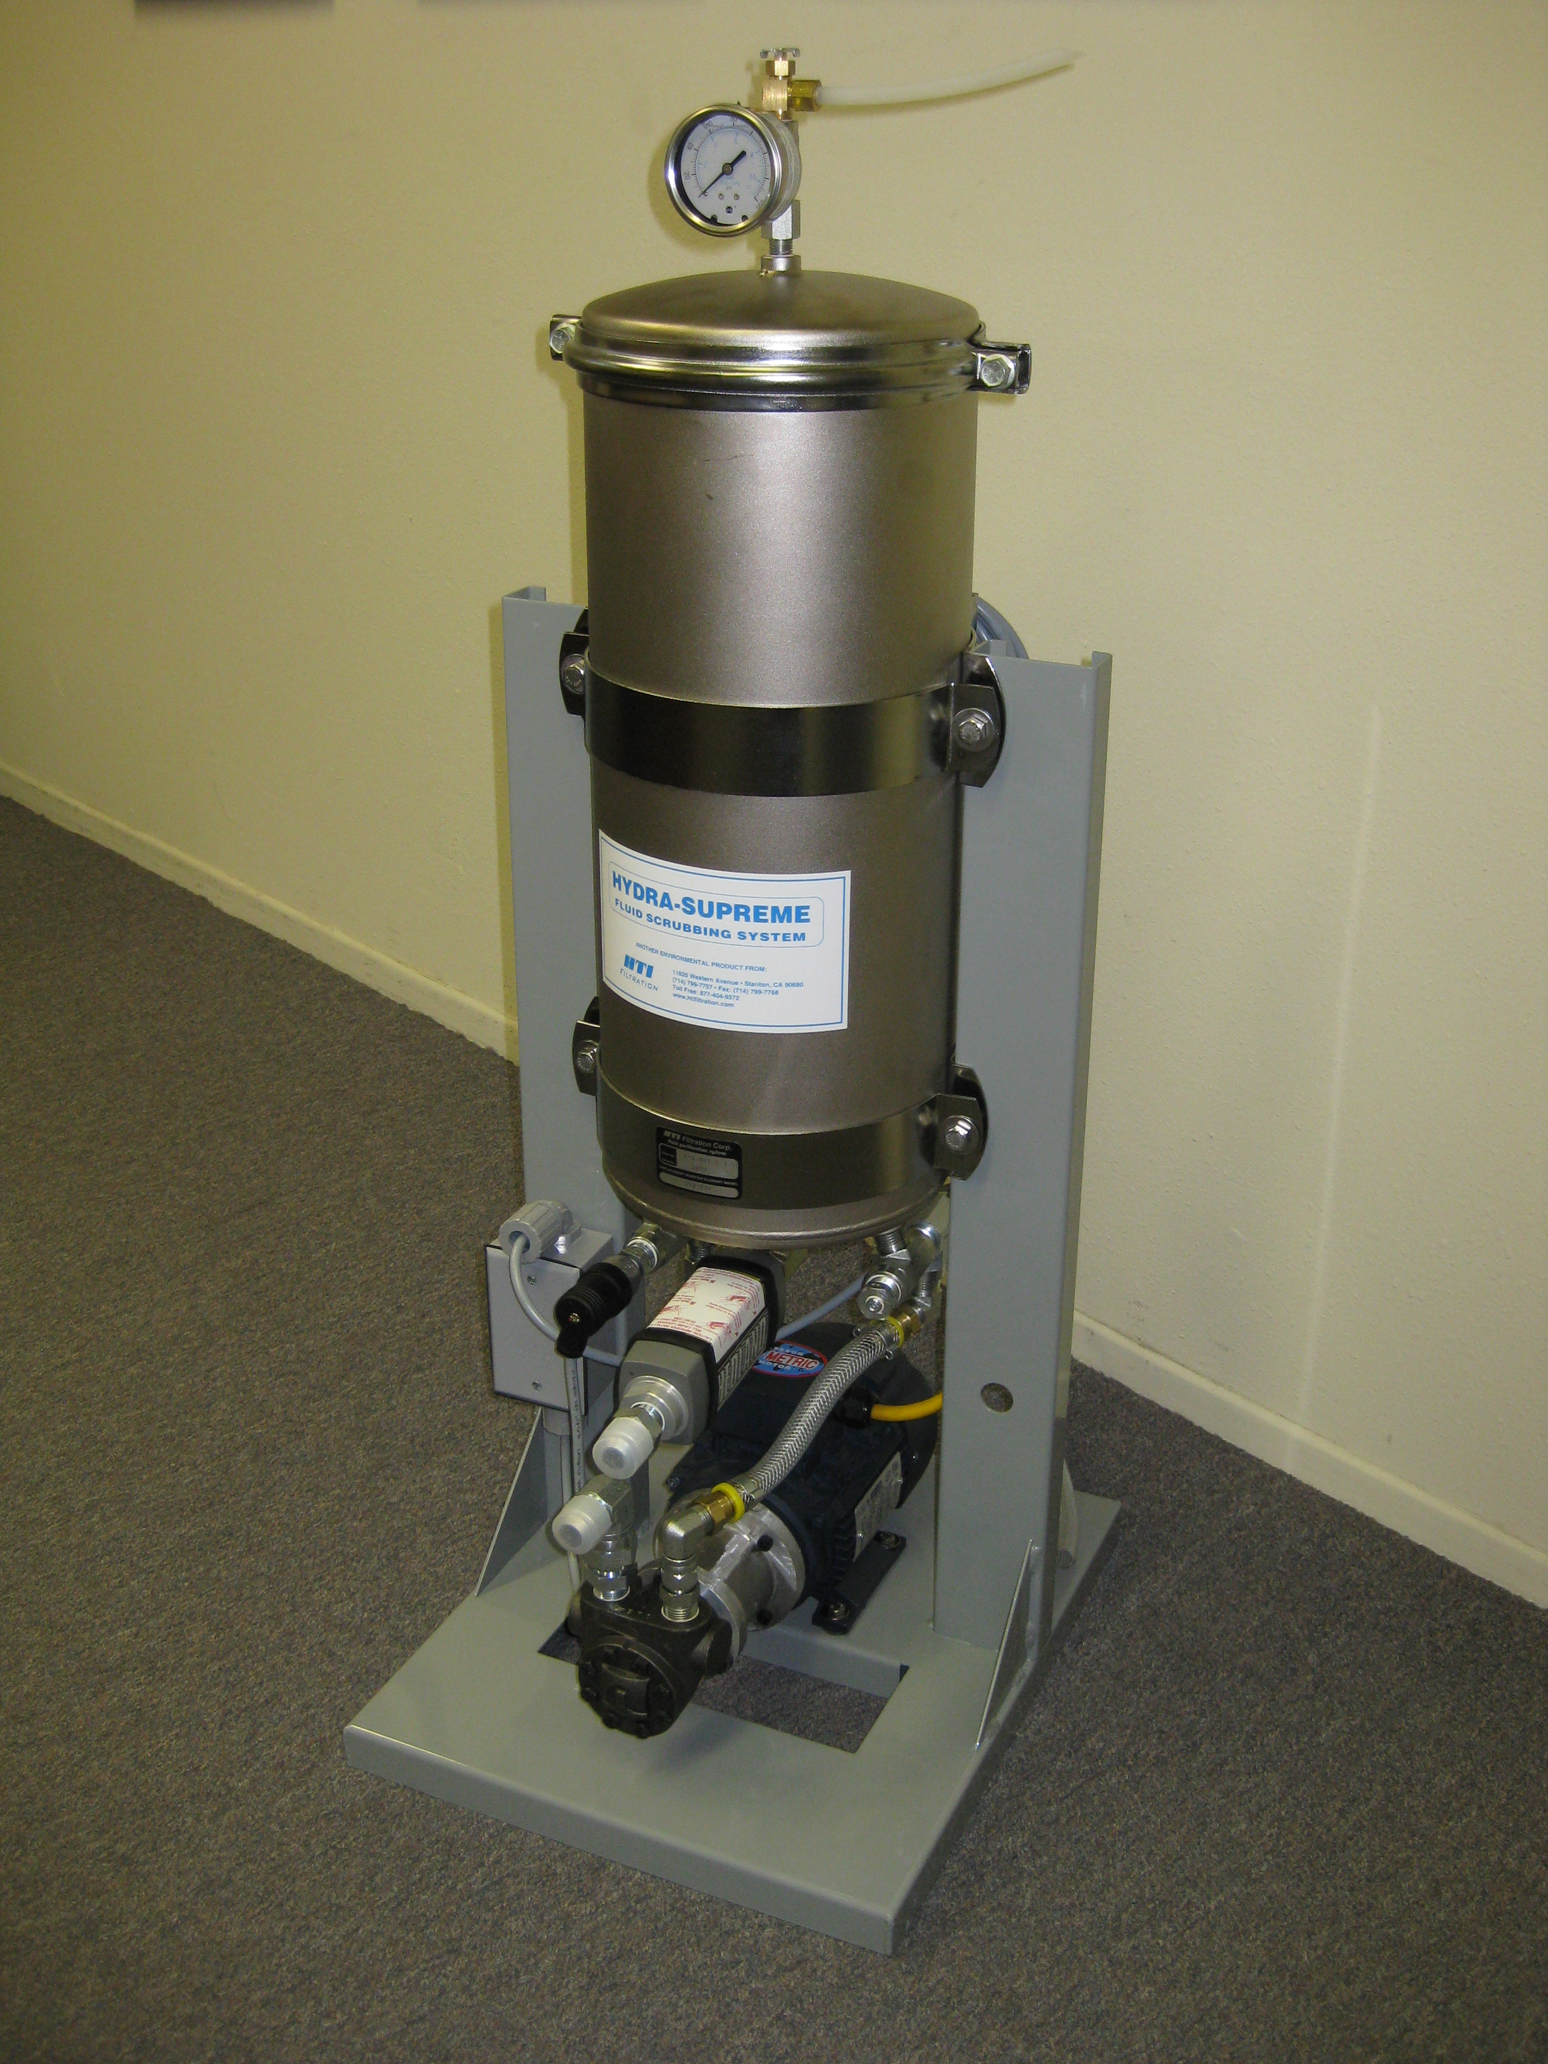
Physical Data:
Height: 42" (107 cm)
Width: 13" (33 cm)
Depth: 18" (46 cm)
Weight: 90 lb. (41 kg)

Material:
Stand- Galvanized steel, powder coat finish
Canister – CRDQ steel, EN finish
Valve and drain plug - Brass

Performance Data:
Pump type: Rotary ring gear, internal relief
Flow: 1.0 GPM (oil: 1000 SUS @ 100°F)
3.8 l/min (oil: 216 Cs @ 40°C)

Electrical Specifications:
Motor - 1/2 HP TEFC 60 Hz 1 ph (-015)
- 1/2 HP TEFC 50 Hz 1 ph (-024)
On/Off Switch at motor junction box
8 Ft. cord with three pronged plug

Connection Data:
Oil inlet - 3/4" male 37' JIC
Oil Outlet - 1/2" male 37' JIC

810-015,024 sys spec 12-29-02

