HTI FILTRATION, INC.

SYSTEM SPECIFICATION SHEET

HS410-C2-B6L-C60 Model # 810-027

Systems Description: The HS410-C2-B6L filtration system, is designed to remove moisture, sludge and metal particulate from the gear lubricant used in two piece can manufacturing equipment. The filtration system features a sturdy, floor mount stand, close coupled rotary ring gear pump and a field adjustable pressure warning light system. The pump and motor are both oversized to compensate for the higher production rates being achieved with the new B-6 Model bodymakers. The D60 designation indicate the 60 Hz electrical service that the motor is designed to operate with. The heart of the system is the unique, high capacity 400 Series Hydra-Supreme filtration element. This patented filter provides long service life and increases productivity by eliminating lee jet blocking, reducing machine wear and greatly extending the effective lubricant life span.

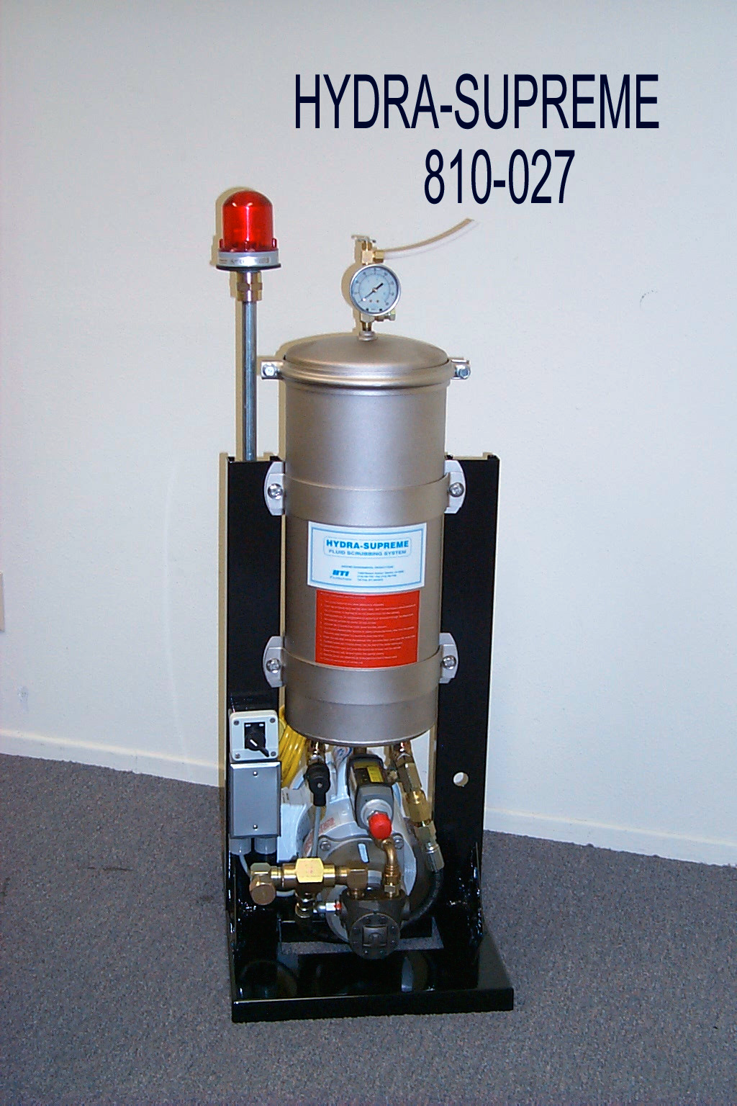Physical Data:
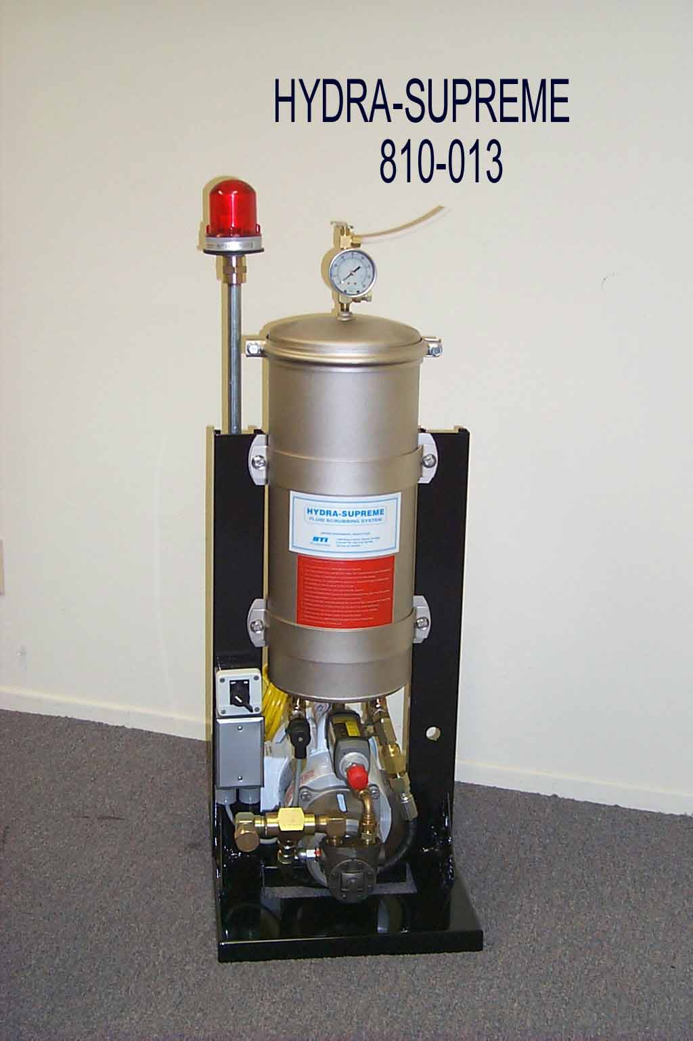
Height: 42" (107 cm)
Width: 13" (33 cm)
Depth: 18" (46 cm)
Weight: 110 Lb. (50 kg)

Material:
Stand - Powder coated, galvanized steel
Canister-EN finished mild steel
Fittings - Zinc, chromate finished, JIC thread
Fasteners - Stainless steel

Performance Data:
Pump type: Rotary ring gear, adjustable internal
relief and fixed external relief

Flow:
1.5 GPM (oil: 750 SUS @ 100°F)
5.75 l/min (oil: 162 Cs @ 40°C)

Water Retention Capacity: 2.0 liters typical

Connection Data:
Oil inlet - 3/4" male 37º JIC
Oil Outlet - 3/4" male 37º JIC

Electrical Specifications:
Motor - 1/2 HP TEFC, Wash Down duty, Class F Insulation, SAE frame 56-C Face
115V/1Ph/60 Hz
Cam type On/Off Switch
8 Ft. cord with three pronged plug

Pressure Warning System- Optional
Pressure switch - AC/DC Field adjustable
Warning light - 60 flashes per minute, 50 Candela

810-013-027 system specification
091712

