HTI FILTRATION INC.

SYSTEM SPECIFICATION SHEET

CANFORMING SYSTEMS FILTER

HS410-C2-B6L-C Model # 810-051.0

Systems Description: The HTI Filtration model 810-051.0 filtration system is designed to remove moisture, sludge and metal particulate from the gear lubricant used in two-piece can manufacturing equipment . It is powered by a dual 50/60 Hz, metric frame three phase motor. The filtration system features a sturdy, floor stand, close coupled rotary ring gear pump, calibrated flow meter and a pressure switch. This system is designed to provide maximum protection for the bodymaker with absolutely minimal maintenance and service. The heart of the system is the unique, high capacity 400 Series Hydra-Supreme filtration element. This patented filter provides long service life and increases productivity by eliminating the lee jet blocking that creates tear offs. Additional benefits are reduced machine wear and greatly extended lubricant life span through the absorption of coolant and trapping of the fine aluminum particles that turn the oil black.

Physical Data:

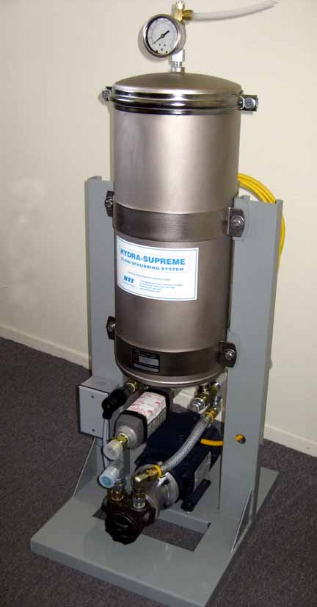Height: 42" (107 cm)
Width: 13" (33 cm)
Depth: 18” (46cm)
Weight: 103 Lb. (47 kg)

Material:

Stand - Powder coated galvanized steel
Canister – Electroless Nickel coated steel
Fittings - Zinc, chromate finished, JIC thread
Fasteners - Stainless steel

Flow:
1.5 GPM (oil: 750 SUS @ 100°F)
5.7 l/min (oil: 162 Cs @ 40°C)

Performance Data:
Pump type: Rotary ring gear, external relief
1.5 GPM (oil: 750 SUS @ 100°F)
5.7 l/min (oil: 162 Cs @ 40°C)
Oil Quality - ISO 4406 17-15-13 typical

Water Retention Capacity: 2.0 liters typical

Connection Data:

Oil inlet - 3/4" male 37' JIC
Oil Outlet - 1/2" male 37' JIC

Electrical Specifications:

Motor -.37 Kw/.5 HP B3 base, 180-380 50 Hz/ 230-460 60Hz metric motor - 575 Volt also available
12 Ft. cable (2) - for high (motor) and low (pressure switch) voltage circuits

Pressure Warning System

Pressure switch – 60 PSI Set,Field adjustable,

810-051 3M system specification

1/02/

