HTI Filtration Inc.

SYSTEM SPECIFICATION SHEET

HC211-XP- B4POPE/ 050OWB-A-SPEC.ASCCR4

System # 830-002.1 -.3
Angelus Part # F 029H614 AAAA0,-AAAB8,-AAAB9

System Description: Hydra Supreme HC211 filtration systems are designed to remove water and particulate from lubricating oil circuits. Our Model 830-002 is a cabinet enclosed system designed to work with Angelus seamer systems and is available only through Angelus Sanitary Can. This system applies the patented Hydro-Fil water bag to absorb free and emulsified water in series with the Hydra Supreme series filter element, which removes both hard and soft particulate from the oil supply. The 830-002 is designed for use with lubricating fluids ranging from 350 to 1000 SUS (at 100 F). Each system comes completely assembled and ready for mounting inside a dedicated cabinet. Each system has a dedicated motor, pump with internal relief valve, flow sensing switch, dual pressure switches, diversion valve and electrical connection box. The canister assembly is designed to tilt outwards to facilitate filter exchanges.

Physical Data:
System Height: 36" (91 cm)
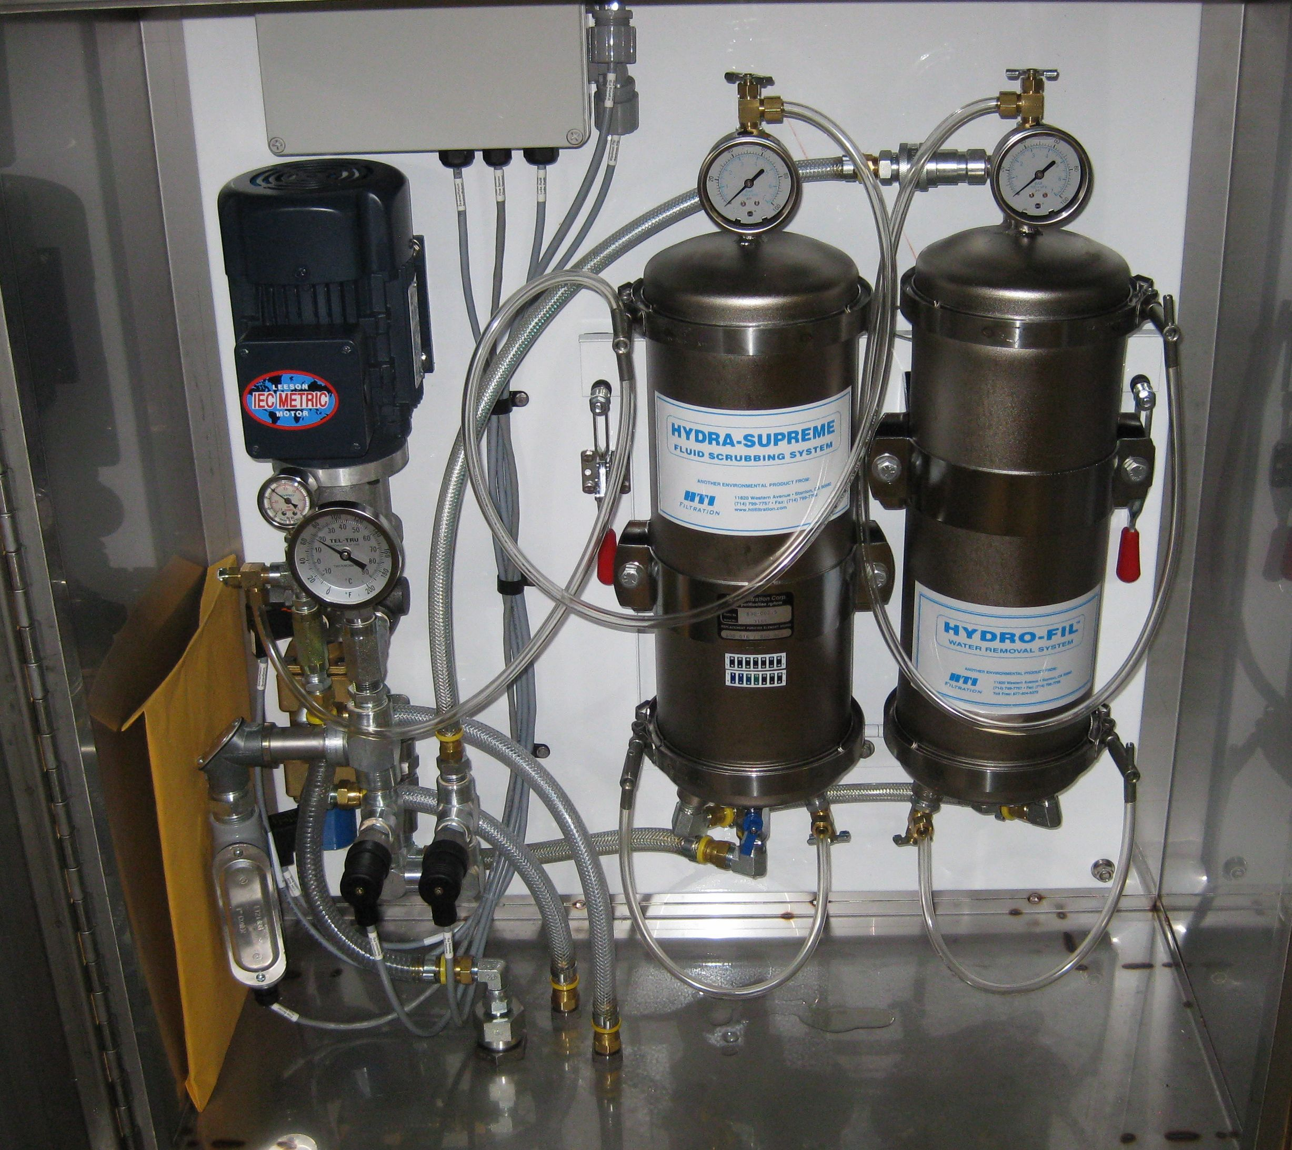
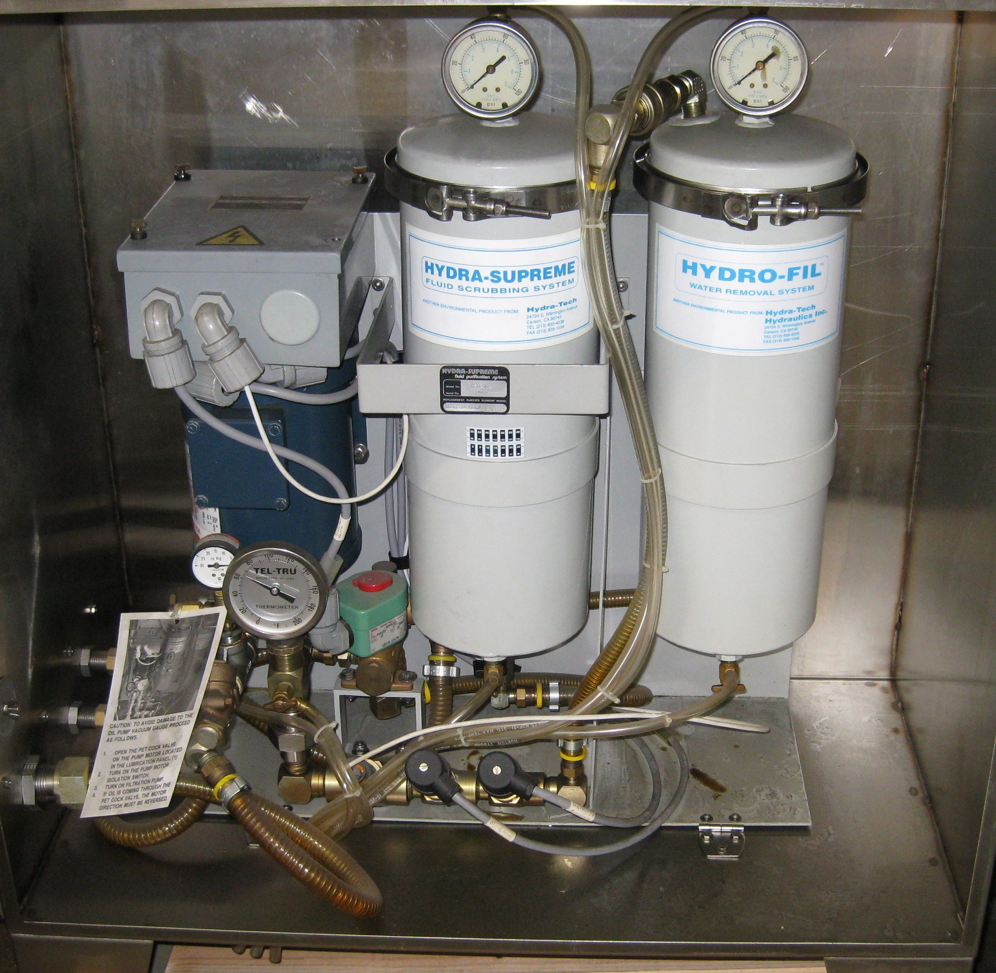
Width: 30” (76 cm)
Depth: 16" (341cm)
Weight: 124 lb. (60kg)

Material:

Cabinet: 316 SS, water resistant

Canisters: Electroless Nickel coated steel

Frame: Epoxy coated mild steel
Pressure Gauges: SS body, Lexan lens

Performance Data:

Pump type: Rotary ring gear, internal relief
Flow: 0.5 GPM (oil: 750 SUS @ 100°F)
1.9l/min (oil: 108 Cs @ 37.7C)

Water Retention Capacity: 2.0 liter typical

Electrical Specifications:

Motor - 1/3 HP TEFC 50/60 Hz 3 phase 190-460 V
Connectors and Rails: DIN EN 50 022, UK 2.5 B
Cables: Olflex 150 (Quatro Approval)

Connection Data:

Oil inlet - 1/2" male 37' JIC
Oil outlet - 3/8" male 37' JIC

Safety Switches:

Pressure Switch: AC/DC 5 amp, field adjustable with DIN cable connector
Flow switch - 24 VDC

Filters:
Hydro-Fil 050OWB Angelus Part # - F029H614 AAAI3
Hydra-Supreme B4POPE- Angelus Part # - F029H614 AAAJ0

830-002 system specification wb 030212

