HTI Filtration Inc.

SYSTEM SPECIFICATION SHEET

HS410-C1-B4H-C

Model # 810-002

Systems Description: The 810-002 filtration system is designed to remove moisture, sludge, varnish and hard particulate from hydraulic fluids used on servo valve equipped systems. The filtration system features a rugged, floor mount stand and comes complete with a dedicated pump, motor and connection fittings. The heart of the system is the unique, high capacity 400 Series Hydra-Supreme filtration element that has proven itself capable of maintaining better than new oil quality over extended periods of time thus greatly extending the time between periodic fluid replacement, maintaining system accuracy and reducing internal wear.

Physical Data:
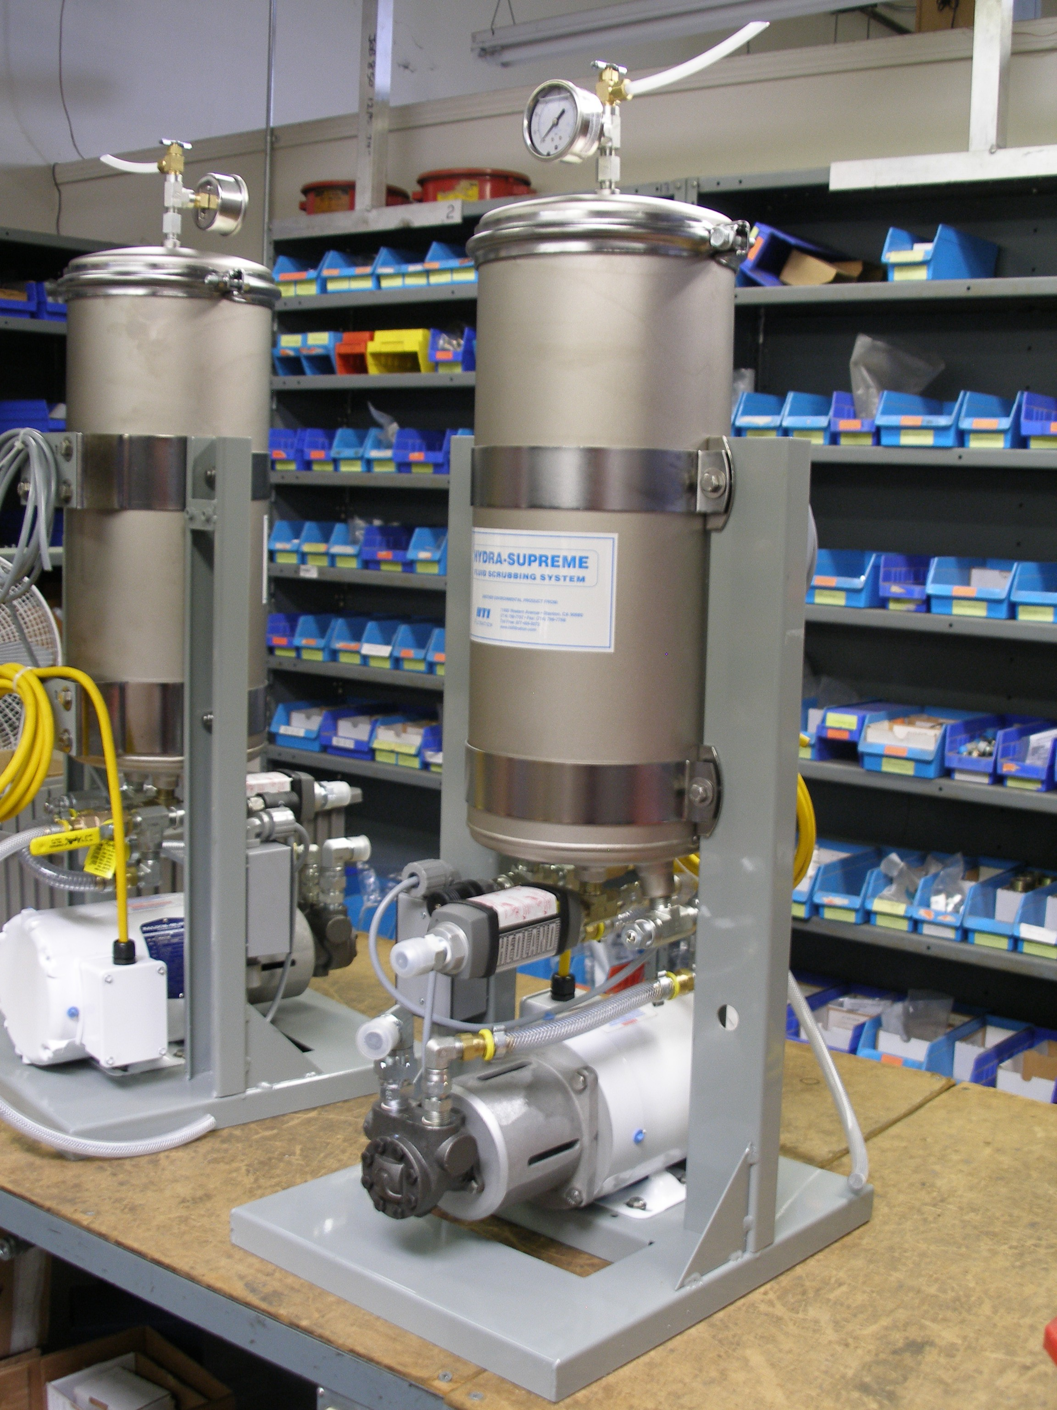
Height: 42" (107 cm)
Width: 13" (33 cm)
Depth: 18" (46 cm)
Weight: 90 lb. (41 kg)

Material:
Stand - Galvanized steel with powdercoat
Canister - Electroless Nickel coated mild steel
Drain valve - Brass

Performance Data:
Pump type: Rotary ring gear, external relief
Flow: 1.5 GPM (oil: 350 SUS @ 100°F)
5.75 l/min (oil: 650 Cs @ 40°C)
Oil Cleanliness - ISO 4406 14-12-09 typical
Beta_{3:}100

Electrical Specifications:
Motor - 1/2 HP TEFC WD 60 Hz 1phase
Rotary On/Off Switch
8 Ft. cord with three pronged plug
or 3 phase, 60Hz SAE or 50Hz Metric motor

Connection Data:
Oil inlet - 3/4" male 37⁰ JIC
Oil Outlet - 1/2" male 37⁰ JIC

810-002system spec 061812

