HTI Filtration INC.

SYSTEM SPECIFICATION SHEET

HS410-CV-B6L-UNP

Models # 810-009

Systems Description: The HS410-CV-B6L-UNP filtration system is designed to remove moisture, sludge and hard particulate from gear lubricants used in Sequa B-5 body makers. The 810-009 models are bolt-on replacements for the Kaydon filters used on systems with cart mounted heat exchangers where the heat transfer tubes are vertically mounted. The heart of these systems is the unique, high capacity B6L Series Hydra-Supreme filtration element that has proven itself capable of maintaining new oil quality over extended periods of time. Using this filtration system eliminates the need for periodic gearbox lube replacement due to increasing water and metal content, reduces tear-off rates by keeping the lee jets open and improves component life by keeping the oil clean and clear. Bodymakers with over 100 PSI normal operating pressure on the heat exchangers will need to add pressure reducing valve kit # 460-013 to maintain a safe operating environment.

Physical Data:
Height: 36" (92 cm)
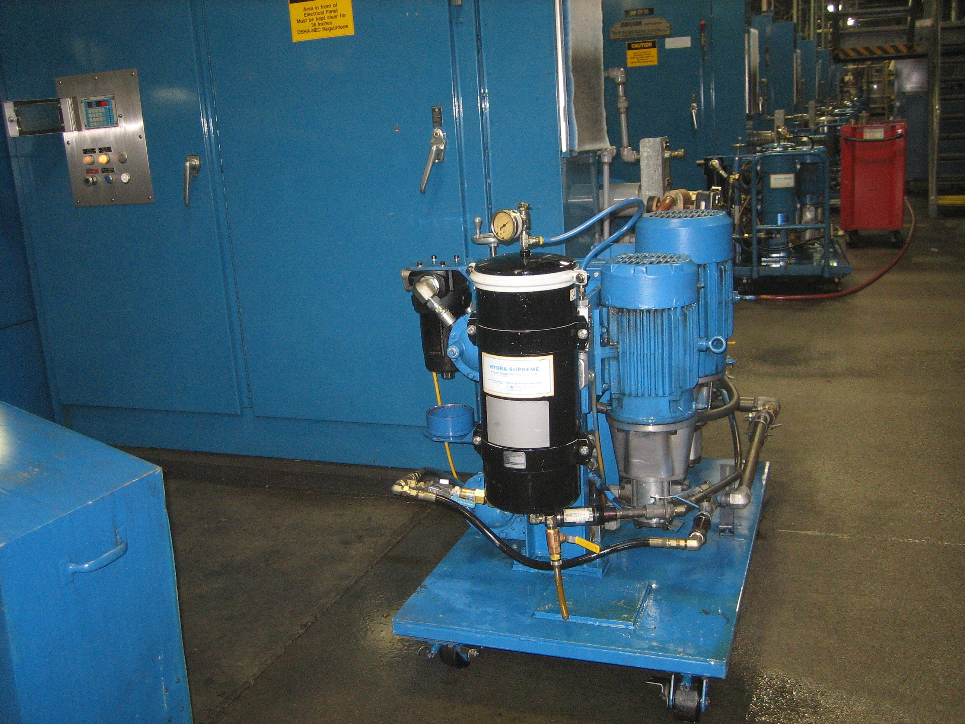
Width: 13" (33 cm)
Depth: 13" (33 cm)
Weight: 60 LB. (41 kg)

Material:
Stand and Canister - Powder coated mild steel
Flow Control Valve - Brass, 300 PSI
Flow Meter - Aluminum body, acrylic scale tube

Performance Data:
Flow: 1.5 GPM (oil: 750 SUS @ 100°F)
5.7 l/min (oil: 108 Cs @ 37.7°C)

Filtration Rating: Beta₃ 90 (typical)

Connection Data:
Oil inlet - 3/4" male 37^{O} JIC
Outlet - 1/2" male 37^{O}JIC

Options:
Pressure Reducing Valve Kit 460-013

810-009 system specification wb 2-22-99

